Experiment 8

Face and Object Detection

# Aim:

To perform Face and Object Detection using Haar Cascade and Object Detection using YOLO V5 Deep Learning Library.

# Software/ Packages Used:

1. Google Colaboratory
2. Libraries used:
   * Opencv – python
   * Numpy
   * Matplotlib
   * tensorflow

# Programs:

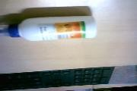**1] Haar Cascade Based Face Detection: POSITIVE IMAGES:**

# NEGATIVE IMAGES:

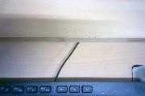

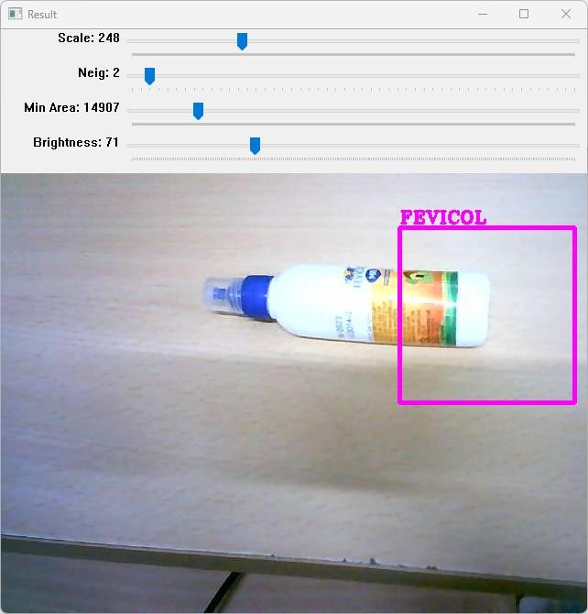**OUTPUT:**

# YOLO v5 Based Object Detection: (both for pretrained and custom data- (i/p -Video, Image, Live Video))

**CODE:**

# Setup:

!git clone https://github.com/ultralytics/yolov5 # clone

%cd yolov5

%pip install -qr requirements.txt comet_ml # install

import torch import utils

display = utils.notebook_init() # checks

from google.colab import drive drive.mount('/content/drive')

# Detect:

!python detect.py --source "/content/drive/MyDrive/datasets/chicken video.mp4"

!python detect.py --weights yolov5s.pt --img 640 --conf 0.25 --source data/images # display.Image(filename='runs/detect/exp/zidane.jpg', width=600)

# Validate:

# Download COCO val torch.hub.download_url_to_file('https://ultralytics.com/assets/coco2017val.zip', 'tmp.zip') # download (780M - 5000 images)

!unzip -q tmp.zip -d ../datasets && rm tmp.zip # unzip # Validate YOLOv5s on COCO val

!python val.py --weights yolov5s.pt --data coco.yaml --img 640 --half

# Train:

#@title Select YOLOv5

logger = 'Comet' #@param ['Comet', 'ClearML', 'TensorBoard']

if logger == 'Comet':

%pip install -q comet_ml

import comet_ml; comet_ml.init() elif logger == 'ClearML':

%pip install -q clearml

import clearml; clearml.browser_login() elif logger == 'TensorBoard':

%load_ext tensorboard

%tensorboard --logdir runs/train

# Train YOLOv5s on COCO128 for 3 epochs

!python train.py --img 640 --batch 16 --epochs 3 --data coco128.yaml --weights yolov5s.pt

--cache

# OUTPUT: IMAGE:

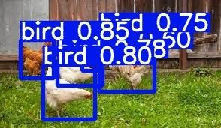

**VIDEO:**

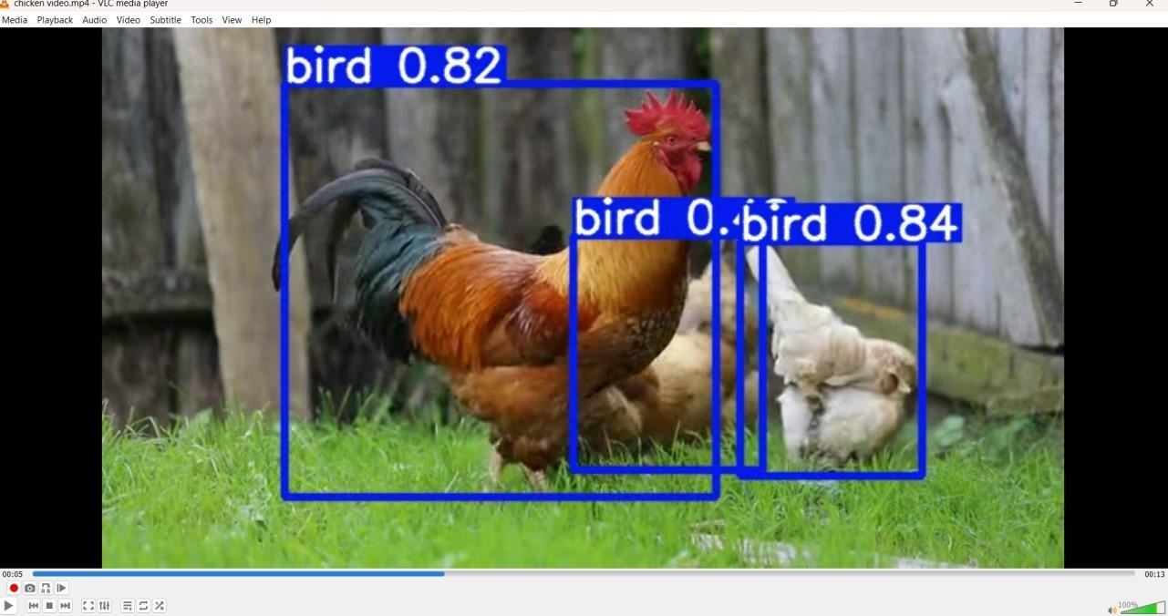

# Object Detection using Deep Learning camera:

**OUTPUT:**

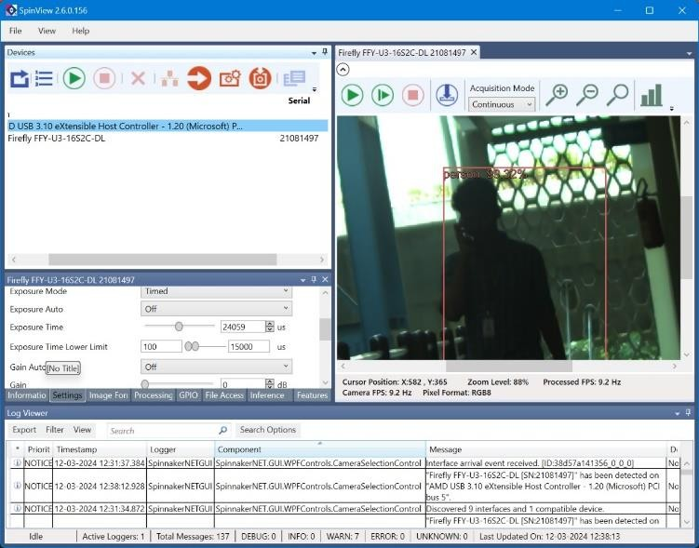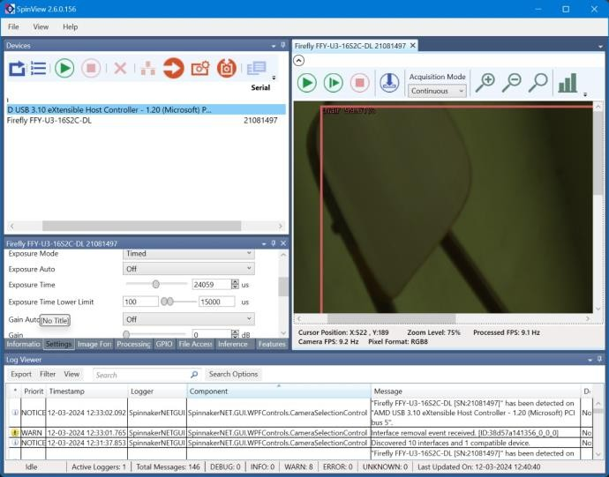

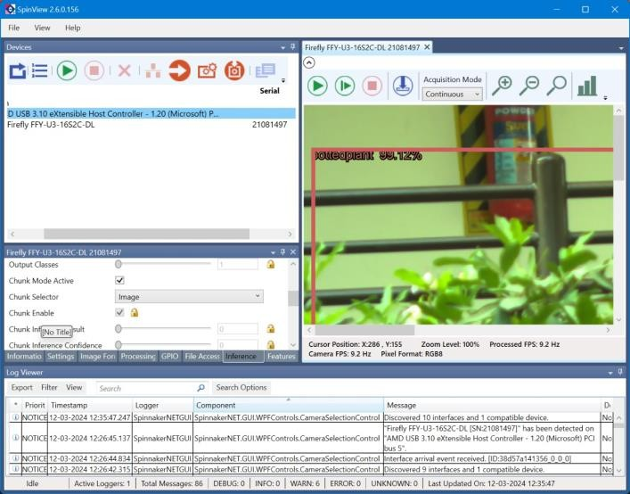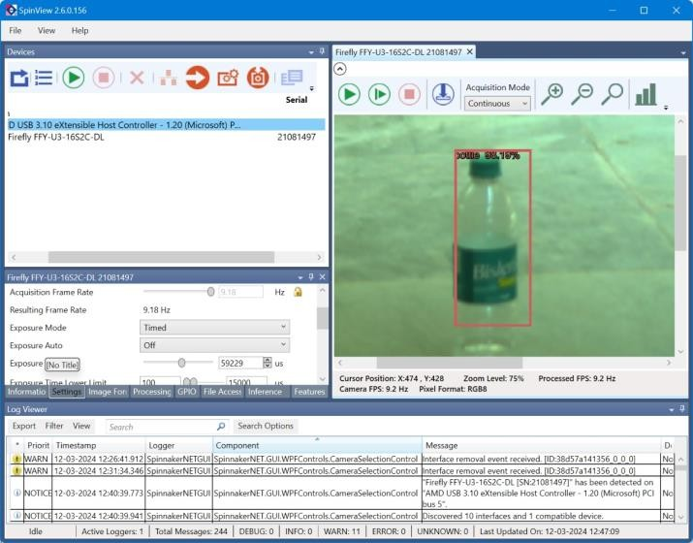

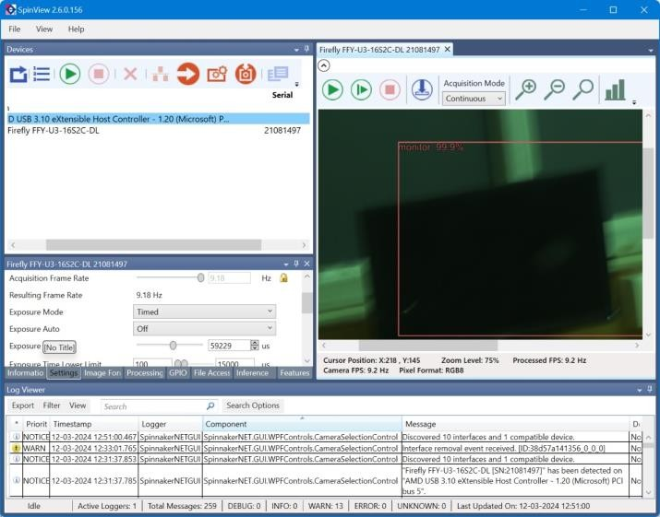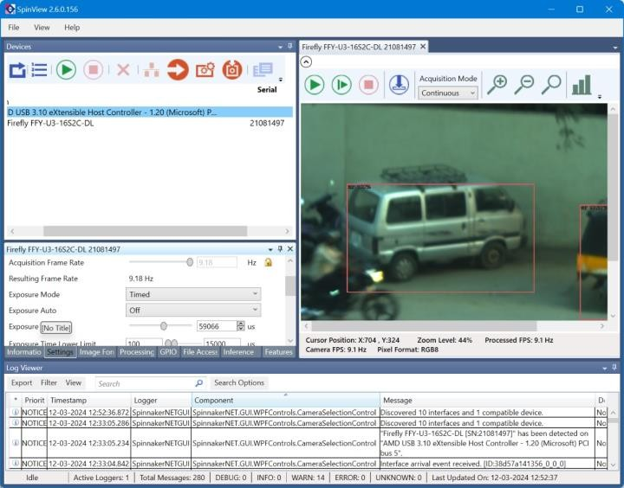

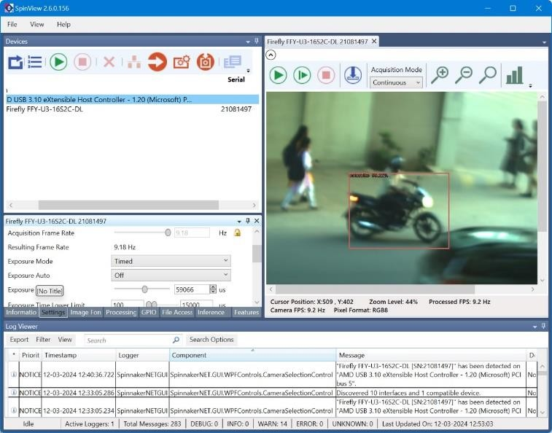 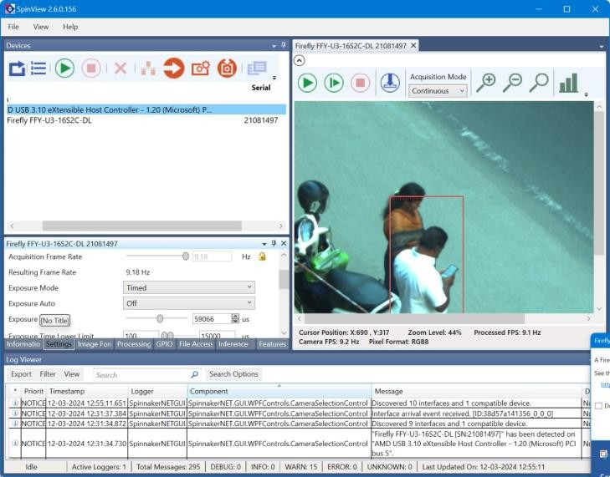

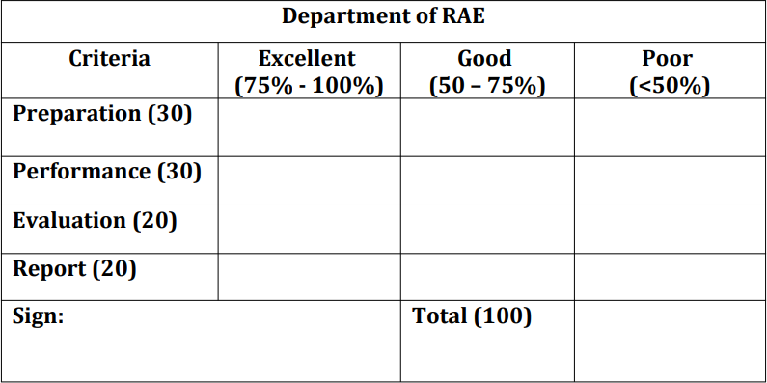

# Result:

Thus, Face Detection using Haar Cascade and Object Detection using Yolo V5 were performed.

# Post Lab Questions

* 1. **What are the key advantages of using Haar Cascades for face detection compared to other methods?**
     + Haar cascades use simple rectangular features, enabling rapid image scanning for real-time face detection, even on low-powered devices.
     + They achieve high face detection rates while maintaining relatively low false positive rates, suitable for security systems and video surveillance.
     + Haar cascades exhibit robustness to lighting conditions and facial expressions, ensuring reliable detection across diverse environments.
     + They are relatively easy to train, allowing for adaptation to specific use cases and environments.
     + Haar cascades are versatile and applicable in a range of scenarios, enhancing their utility for various applications.

# What is the difference between ANN & CNN.

* + - ANNs consist of interconnected layers of nodes, while CNNs utilize convolutional layers for feature extraction.
    - ANNs are used for tasks like regression, classification, and pattern recognition, while CNNs are specialized for processing grid-like data such as images.
    - CNNs employ convolutional layers to extract features from input images efficiently.
    - CNNs utilize hierarchical structures to learn increasingly complex features, particularly effective for tasks like image classification and object detection.
    - CNNs excel in tasks involving visual data due to their tailored architecture for image processing.

# For the following image perform the convolution operation. Also perform Max pooling, Min pooling and Average pooling on the input image.

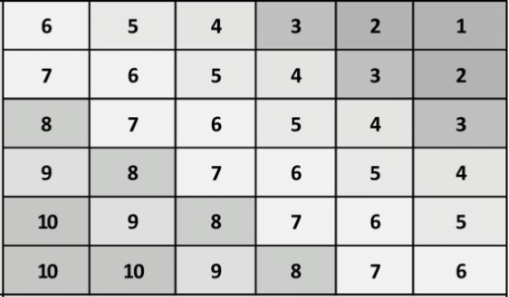

|  |  |  |
| --- | --- | --- |
| 3 | 2 | 4 |
| 2 | 0 | 2 |
| 4 | 2 | 3 |

|  |  |  |  |  |  |  |
| --- | --- | --- | --- | --- | --- | --- |
| Input Matrix: | | | | | | Filter Matrix: |
| [[ 6 5 4 3 2 1] | | | | | | [[3 2 4] |
| [ 7 | 6 | 5 | 4 | 3 | 2] | [2 0 2] |
| [ 8 | 7 | 6 | 5 | 4 | 3] | [4 2 3]] |
| [ 9 | 8 | 7 | 6 | 5 | 4] |  |
| [10 9 8 | | | 7 | 6 | 5] | |

[10 10 9 8 7 6]]

Output Matrix after Convolution: [[132. 110. 88. 66.]

[154. 132. 110. 88.]

[176. 154. 132. 110.]

[194. 176. 154. 132.]]

Input Matrix:

|  |  |  |  |  |  |
| --- | --- | --- | --- | --- | --- |
| [[ 6 | 5 | 4 | 3 | 2 | 1] |
| [ 7 | 6 | 5 | 4 | 3 | 2] |
| [ 8 | 7 | 6 | 5 | 4 | 3] |
| [ 9 | 8 | 7 | 6 | 5 | 4] |
| [10 | 9 | 8 | 7 | 6 | 5] |

[10 10 9 8 7 6]]

Max Pooled Matrix: [[ 7. 5. 3.]

[ 9. 7. 5.]

[10. 9. 7.]]

Min Pooled Matrix: [[5. 3. 1.]

[7. 5. 3.]

[9. 7. 5.]]

Average Pooled Matrix: [[6. 4. 2. ]

[8. 6. 4. ]

[9.75 8. 6. ]]